Database Assignment

### Purpose and End User of my database

| The purpose of my database is to show the users the basketball(NBA) data they need. For example if the user wanted to find out which team their favorite NBA player plays for or even which player won the NBA MVP award in any selected year. The end users for my database would be people interested in basketball. |
| --- |

### Describe at least 3 implications that are relevant to your database and its use by the end user and why they are important

| **FUNCTIONALITY**  The definition for functionality is the ability to perform a task or function. In a database it is very important that your code/program actually functions for the user. For example if the user wanted to find out the player's age or which team the player plays for, the database will need to be able to print out the correct answer. This is very important because if a database does not function there is no point in it.  **USABILITY**  Usability in a database is crucial. Usability is the degree to which something is able or fit to be used. If your database is very hard to use or more usable towards a certain group of people, the usability won’t be great as it’s not easy for everyone to use. For example if your database contains a lot of jargon it will limit the amount of users as not all people may understand what the jargon means. It is very important to create a more usable database as more people will be able to use it.  **ACCESSIBILITY**  In a database it is important that your database is accessible to many people. This means, removing the barriers that keep you from leveraging the data in your databases to its fullest. Easily accessible data enables the user to find there wanted things faster. This may be achieved by labeling things properly and limiting the usage of jargon as this may limit the user from accessing what they wish. |
| --- |

### Database Design- Your Entity Relationship Diagram.

|  |
| --- |

### Database Testing Table: SQL Statements

| **Purpose** | **SQL Statement** | **Result Success?** |
| --- | --- | --- |
| List all players names | SELECT first_name, last_name FROM player | Successful |
| List born years from players | SELECT born_year FROM player | Successful |
| List which player won mvp in which year | SELECT player_id, year FROM mvp | Successful |
| List player and team | SELECT player_id, team_id FROM team_player | Successful |
| List what team a player is in what team | SELECT player.first_name, player.last_name, team.team_name FROM team_player  JOIN player on player.player_id = team_player.player_id  JOIN team on team.team_id = team_player.team_id | Successful |
| List which player won mvp | SELECT player.first_name, player.last_name FROM mvp  JOIN player on player.player_id = mvp.player_id | Successful |
| List which player won mvp in which year | SELECT mvp.year, player.first_name, player.last_name FROM mvp  JOIN player on player.player_id = mvp.player_id | Successful |
|  |  |  |
|  |  |  |
|  |  |  |
|  |  |  |
|  |  |  |

### Relevant Implications- Explain how your database addresses the relevant implications that you identified at the start.

| My database functions well. It does what it's supposed to do, performing a task/function without issues. It is able to find things such as which player won mvp in which year with a sql statement of SELECT player_id, year FROM mvp.  Usability in a database is crucial. If your database is very hard to use or more usable towards a certain group of people, the usability won’t be great as it’s not easy for everyone to use. So because my database is on basketball the usability isn’t great as it’s more usable towards a certain group of people. But I tried my best to make it at least easier for people that don’t play/like basketball when using my database  My database is accessible because it can be used by anyone. Although it may be more accessible to some than others, I limited using too much jargon as that could even further make the database less accessible to those who don’t have a big knowledge on basketball. |
| --- |

### Showcase:

Give evidence of your database and the Python code that interfaces with it. Use screenshots or a short video. Explain how it improved, how it functions, how it was tested etc.

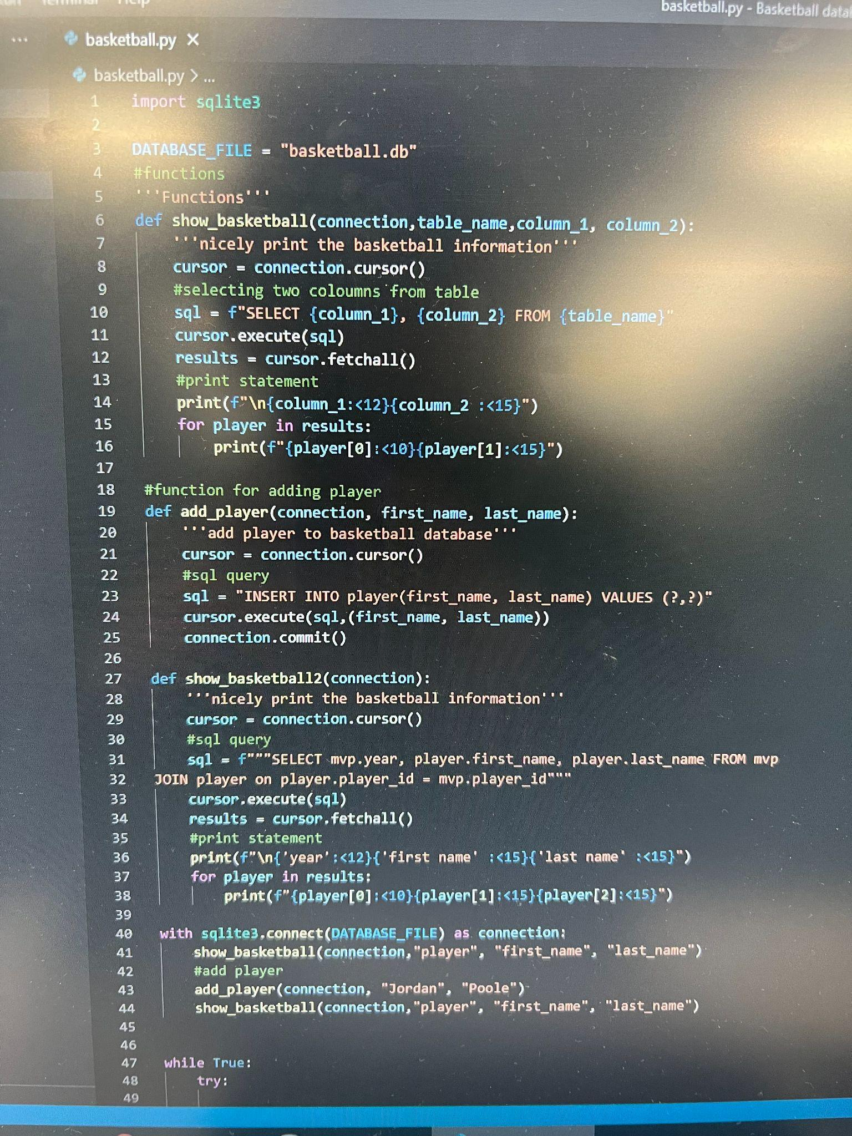

These are the functions from my database

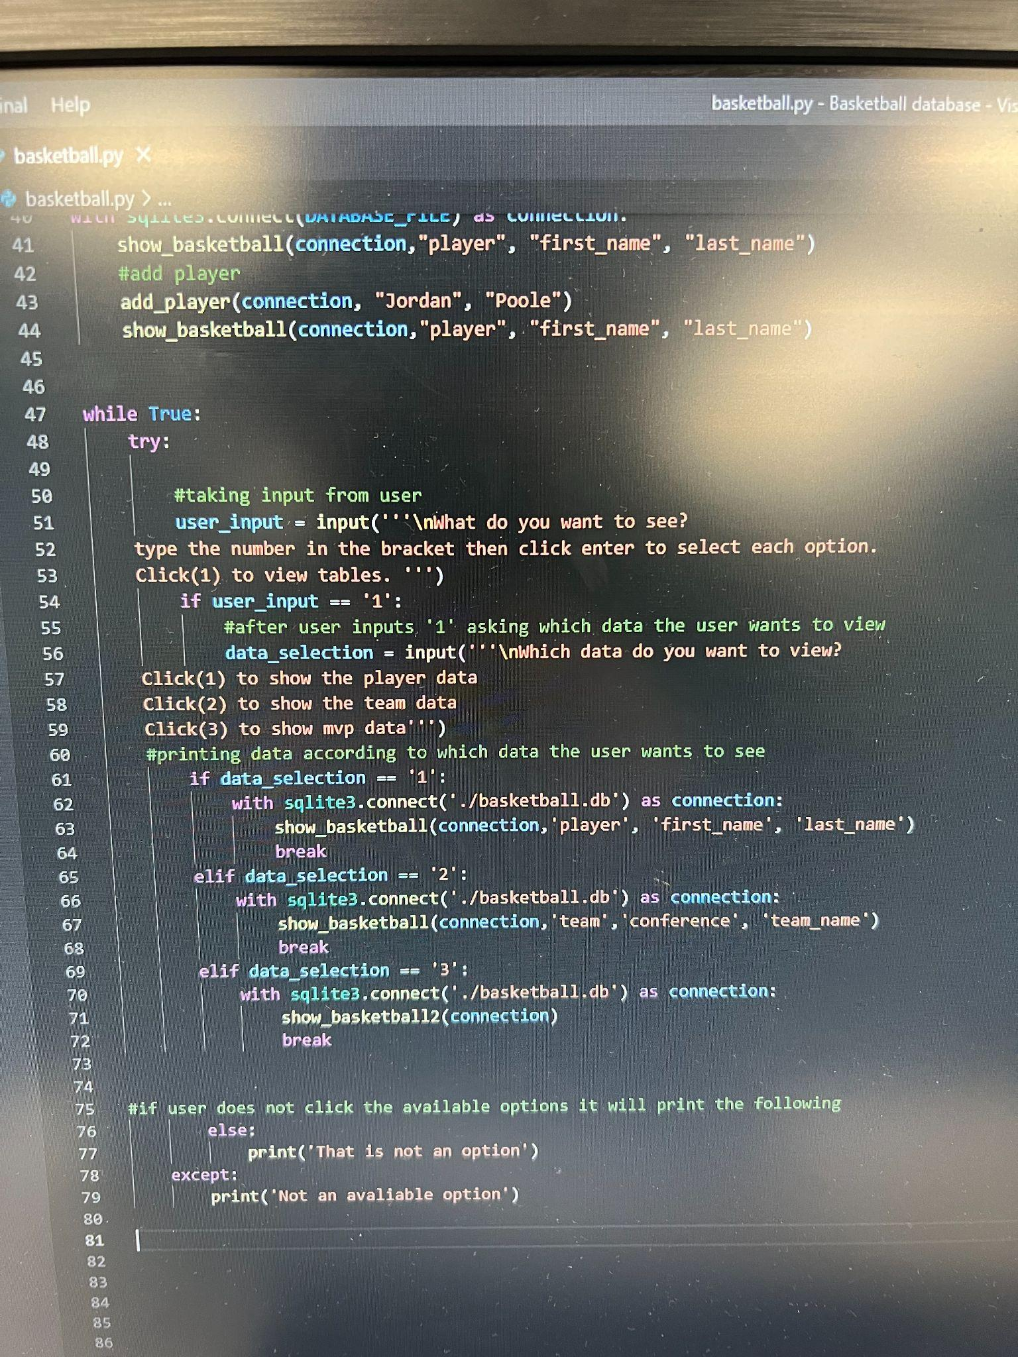

This code asks the user for what they want to see and then once they click 1,2 or 3 to view their wanted data, the code will print the data. If the user puts in something like ‘hi’, ‘5’, or some other input, it will print ‘that is not an option’ and the code won’t crash.

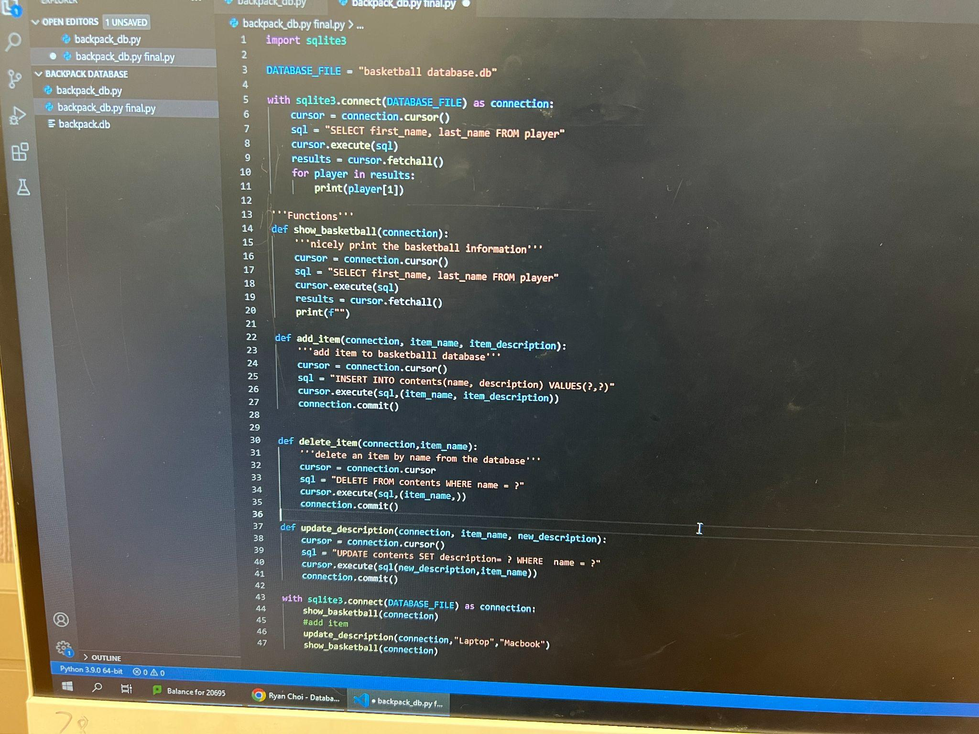

These are the functions from before which I changed up to suit my database to use.

|  |
| --- |

**Teacher Checklist:**

**AS91879- Develop a digital outcome to manage data**

| Achieved- Develop a digital outcome to manage data | **Evidence** |  |
| --- | --- | --- |
| using appropriate tools and techniques to structure, organise, query and present data for a purpose and end user | Structure+organise yes but no to query and present- you didn’t even have a query to meet your one goal- to see what team a player was in.  EDIT:  Please at the very least change your program to use the useful function “show_basketball2()” that achieves the purpose of your database (to show players and their team) | ✓ |
| applying appropriate data integrity and testing procedures | No- EDIT: Made required fixes | ✓ |
| describing relevant implications. | Yes | ✓ |
| Merit- Develop an informed digital outcome to manage data |  |  |
| using information from testing procedures to improve the quality and functionality of the outcome |  |  |
| structuring, organising and querying the data logically |  |  |
| addressing relevant implications. |  |  |
| Excellence- Develop a refined digital outcome to manage data |  |  |
| iterative improvement throughout the development and testing process |  |  |
| presenting the data effectively for the purpose and to meet end-user requirements. |  |  |

**Develop a computer program**

**Credits:** 4 (Internal)

**NZQA:** <http://www.nzqa.govt.nz/nqfdocs/ncea-resource/achievements/2018/as91883.pdf>

| **Achieved**  **Develop a computer program** | **Evidence** |  |
| --- | --- | --- |
| Wrote a program that performs a specific task using a suitable programming language | Did you even run it? It crashes immediately.  It still doesn;t achieve the purpose- see comments in the database marking schedule above.  EDIT:  Add EVERY time it wuns it adds another Jordan Poole incorrectly to the database! FIx this and it might pass  EDIT AGAIN: Finally made it work as expected | ✓ |
| Set out the program code clearly | No logical structure at all- plan what you want, in the order that you need it and slowly build up the code testing all the time.  EDIT_ still doesn;t achieve your only goal but it is slightly more logical.  EDIT AGAIN: Got there in the end | ✓ |
| Documented the program with comments | There is literally one comment. That is nowhere near enough:  EDIT AGAIN: Finally added some comments | ✓ |
| Tested and debugged to ensure that it works on a sample of expected cases | Clearly not.  EDIT AGAIN: It now works as expected. | ✓ |
| **Merit**  **Develop an informed computer program** |  |  |
| Documented the program with variable names and comments that describe code function and behaviour |  |  |
| Following conventions of the chosen programming language |  |  |
| Tested and debugged the program in an organised way to ensure it works on expected and relevant boundary cases |  |  |
| **Excellence**  **Develop a refined computer program** |  |  |
| Ensured the program is a well structured logical solution to the task |  |  |
| Making the program flexible and robust |  |  |
| Comprehensively tested and debugged the program |  |  |

Comments:

Final grades will be decided using professional judgement based on a holistic examination of the evidence provided against the criteria in the Achievement Standard.